The Kandel Adventure

Friday, March 27, 2015

Back to Juba

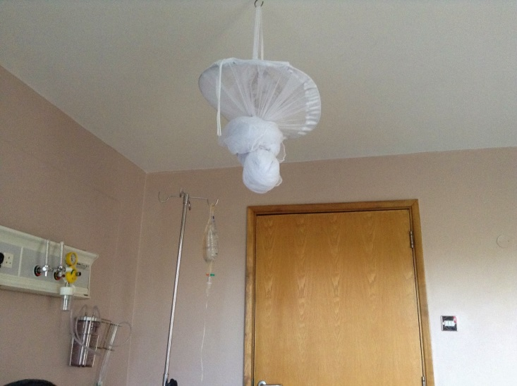
mosquito net over the hospital bed :)
I have waited to write anything until we got back to Juba so that I could do an update on everything at once.
Lynn did get an MRI and a CT scan done. The scan showed one large stone and several smaller stones right behind it so no wonder he was in a lot of pain. All the tests they did that first day came back kind of scary, they said his kidneys were working at less than 50% and other numbers were off also. Not what you want to hear when you are far from home. On day 13 of pain he finally passed the stone but by then he was so worn down it was hard for him to eat and drink like he needed to and he ended up in the hospital with dehydration and a fever but was discharged after only 2 nights in the hospital.
I feel like the last 2 weeks would need about 6 blogs just to get caught up!
Some things we learned:
1. Every time you go to the Dr or get any kind of test done at the hospital you need a letter from your insurance promising to pay the bill. It does not matter if you were there the day before for the same test, you better have a letter.
2. God provides support where ever you are.
3. I (Sharon) do not have any patience for dealing with people in the States who are supposed to know how to handle things, insurance wise, in another country and don't believe me when I say I cannot get a certain phone number for them.
4. It is easy to pick up with friends you have not seen for 20+ years
5. The food in the hospital was served stove hot.
6. God is good!
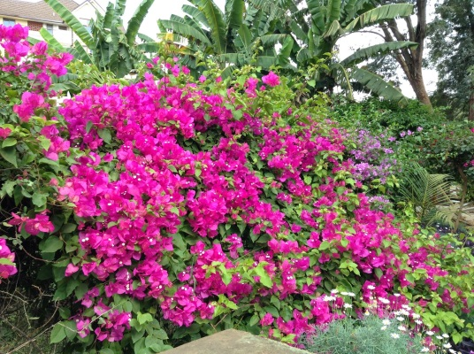
I love that whenever we go to Nairobi we see beautiful flowers!
7. Even good guesthouse food gets old after 2 weeks.
8. Even with all the uncertainty at first with Lynn's health, we felt the prayers of you all and we knew that God was in control - even when it was hard for us to pray.
9. In Kenya, Lynn is a girls name only, so at the hospital everyone was getting a good laugh out of his name. Yes, Lynn fed into the jokes all the time.
Lynn did get a real ego boost our first day in Kenya. When we went down to get an appt. for the MRI the lady there wanted to know where the person was who was getting the MRI. When I pointed at Lynn, who was standing right there and talking to her she said there was no way Lynn is 60 years old! She was looking behind us to find an old man :) She thought Lynn was 45!!
We did enjoy getting away from the heat of Juba and even though I would not call it a relaxing time away we were still ready to get back to Juba and try to get into a normal routine again. We are hoping to find another language teacher and continue with learning Arabic.
There is really no way I can express how much your emails meant to us during that time. I know some of you felt like you did not want to "bother" us but reading those is no bother and I answer as I can.
Please continue to pray for Lynn to gain strength. Pray also for South Sudan.
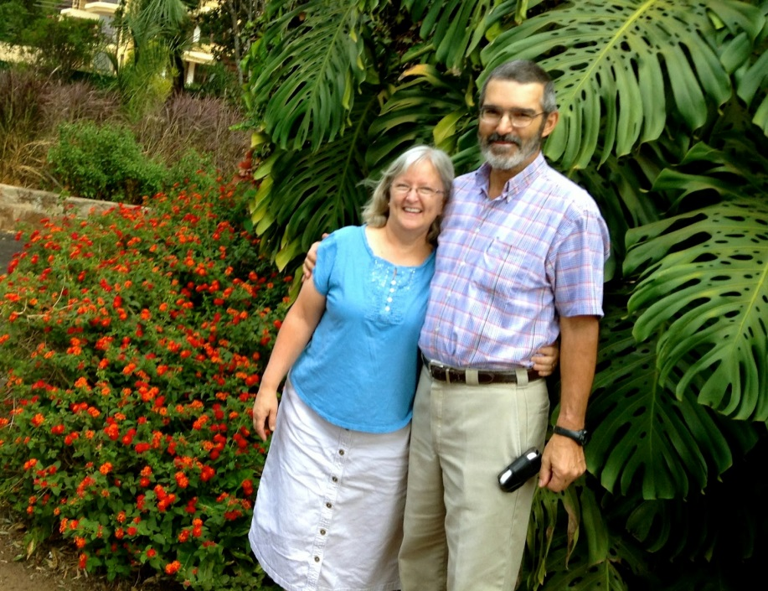
Headed back to Juba!

