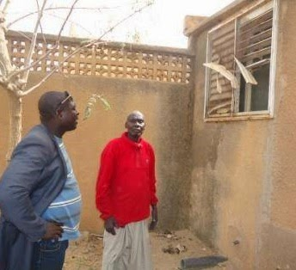
The Ludwigs
My favorite story from last weekend’s troubles is about the Muslim neighbors who saved a 73 year-old pastor and family from their burning house (the in-laws of one of our friends). A mob had broken into their house, taking and breaking things, and then lit fires, so that the old man and family were caught in a room nearly suffocating from the smoke. But when some neighbors saw the smoke and realized what was going on they came and broke in a window to pull the family out. In the house their books were in ashes and only the iron frame of their beds was still standing. The pastor stated, “I have forgiven everything because those who burned my house did not know what they did.” And he invited them to “learn better their religion for it does not teach what they have done.”
The old pastor, the neighbor, the broken window
Elsewhere a medical clinic and guesthouse run by our partners was threatened by a mob four different times. But each time their Muslim neighbors (we mentioned we had a chance to mourn with some of them in an earlier post) convinced the mob to not burn this place that offers them so much help. They even had to physically scuffle to push the crowd back at its worst. Here, our language teacher’s teenage son has Muslim friends who slept outside his house overnight to deal with anyone who would try to attack. We also heard of a small town pastor with a Muslim friend who called him to forewarn him and then rushed with his pick-up to get the pastor’s family to safety before the mob got there. The stories go on like that, but I think it’s also notable that government leaders have repeatedly said those who have done this violence have “failed to understand anything about Islam.” This seems like a pretty strong condemnation of this type of action socially and religiously.
Being Village Guests
Last weekend we went to visit the village of Mary, our former guard’s wife. When she was mourning her husband, her mother Rabi came to stay with her, and we got to know the mother a little and two girls her mother was raising. One of the girls died recently, and since Mary hadn’t been able to go back to her village since then, "La Maestra" had talked with Mary that it would be a good chance for us to give our condolences and bring Mary and the uncle she lives with as well. After about 30 mins. on the main road and then another 30 mins. going on sandy paths through two other villages, we made it to the right place. As soon as we got out of our car, Mary’s father came and led us with a great big smile through the curious crowd, down a winding alley to his yard. One of the strangest experiences of the trip was having him take me by the hand and lead me on as if we were close companions (hand holding is only normal to see here among one’s own gender). They dusted off their two chairs, got out some mats, and sat down to greet us. They had Mary sit on a little stool that we often see women sitting on.
Next there were extended greetings and many neighbors/relatives coming to greet as well. Then we watched while Mary and her family shared news with each other, as they don’t spend time talking on the phone since it is so expensive here. She told the story of her oldest son’s recent bike accident, and with tears her mother re-told the story of the girl’s sickness and death. There were about 25 people standing around the yard to share in the conversation, although most of the men had gone off to talk with the uncle and another neighbor. We saw some “hardships” that the family would speak of whenever we complimented their house or village. There was a girl laying out in middle of their “barnyard” type of yard, near some goats and in the sand and sun, throwing up and moaning. Adults would go over and check on her from time to time, but it seemed a strange way to take care of someone with malaria or other sickness. "La Maestra" also gave some attention to a new mother who was a normal part of the crowd, although it was apparent her 25 day-old baby was in bad shape, tiny and not responding to attempts at feeding.
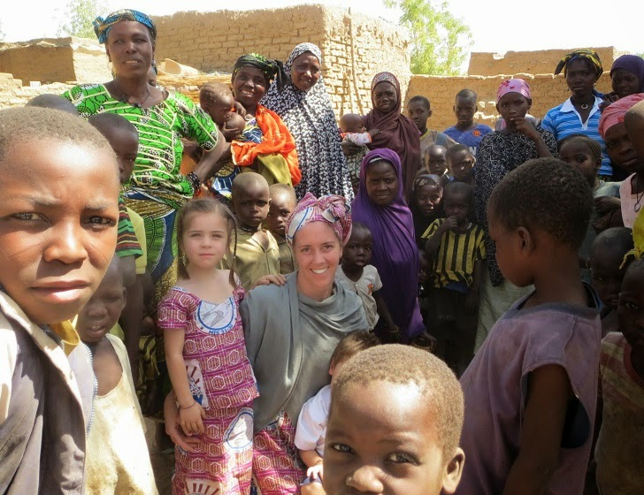
Then we were absolutely blown away by how the family rounded up the only three chickens that I saw in the yard, and presented them to us as a gift to thank us for coming and thank us for helping Mary after the death of her husband. My first thought was that there is no way we can take this gift, when we have no need of chickens and these people have so little. But it’s a lot more complicated than that of course, and so we accepted them in the spirit of the joyful giving, and will now try to figure out how to care for chickens here. We know that the gift their culture holds important is the continued relationship and friendly support of their daughter when other opportunities arise. As we were leaving the mother and father repeated over and over their thanks for our visit and said that we were family to them. In a neighboring village we visited with the guard’s brother and mother in a similar way, and then made it back home after a full morning experience. We were very glad at the opportunity although it was definitely a little overwhelming for our children who are probably gawked at the most!

