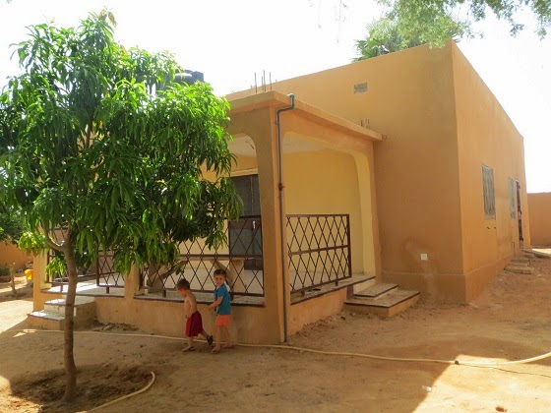
Rachel and Michael Ludwig Serving God in Niger

We moved into the house we’re renting last week and so haven’t had much time or access to internet to give updates about how things are going. We are very happy to be moved in though! We finally unpacked and found a lot of things we forgot we packed, and have now been able to get the materials out to start school with the kids.
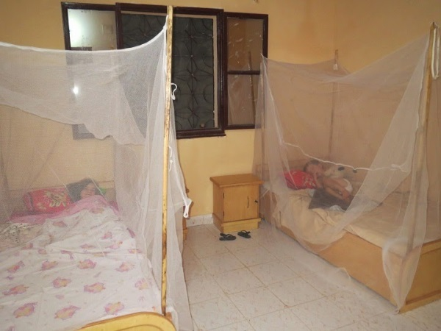
To give you a little description: our house is near the edge of town where houses are popping up fast, but we still have a lot of empty lots around us. It has three bedrooms, one of which we use for school, a dining room attached to the living room, and a kitchen with a pantry (but no shelves whatsoever!). There are friendly neighbors across the street/alleyway with boys who have slingshots and an interest in climbing trees. We have almost a dozen fruit trees (mostly too young to give fruit) squeezed inside the wall that surrounds the house. The yard has 0% of the grass to mow that we had in the States, but is mostly sandy with lots of construction debris and odds & ends. The house is made of concrete block covered on the outside with a sort of sandy coating that was blasted on wet and the roof is slanted corrugated metal. We’re the first house on our immediate block to have electricity brought in (thank God for the amazing quickness with which it happened), and in the minority of people who have running water, so people sometimes come in to use our outside hose. The pleasant surprises have been the tinted glass in the windows which does cool down the direct sunlight a bit and the best flushing toilet I’ve found in Niger so far (you don’t need to pour a bucket to assist it)!

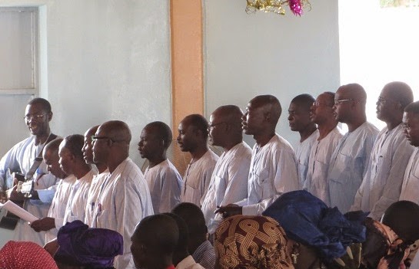
The Day of Men

Last week was the wildest worship service we’ve been to so far. The Men’s Fellowship Group was in charge of worship, which made the pastor say the week before that he was sure would be an adventure. The great part about it was that the men really came together to do some special things with music and skits. Also, one of the men preached a message about the relationship of men to their families and God, and they sang a few more songs as a men’s chorus than they usually do.
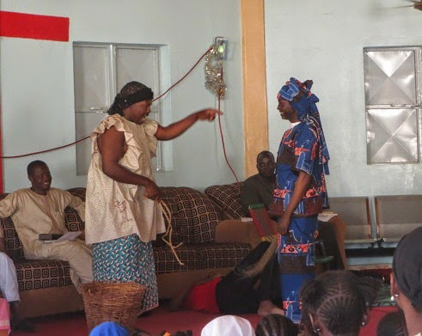

The skits were fascinating though, because even in this relatively conservative society, the men felt free to dress up as women in their skits and really ham it up (which everyone thought was hilarious). They used the skits to caricature how families often expect the father to relate to them in not very active ways and so in practice they don’t respect him much. It was a fun and thoughtful way of presenting the topic and commenting on how they desire to follow Christ personally and let Christ’s way be the authority they point to in their families. I’d like to see more men’s groups in the States (period…) do this sort of thing.

TV Violence
The teenage boys who hangout at our guest house have the TV on anytime we let them, and while we find it annoying since we don’t like to waste much time on TV, it has been very interesting to see what is being shown through satellites mainly from Egypt, Ghana, and N’geria. There are a ton of music video channels, with a mix of blinggy artists doing their thing to more traditional sounding drum beats and high middle-eastern-like singing, or straight-up rap, or more gospel sounding music. The most interesting though are the soap-opera like movies/sagas that depict either a more rural tribal setting or a more urban and muslim setting. Most of these are about people who love each other but aren’t allowed to be together, or about conflicts between multiple wives, or some other tragedy that ends by showing the power of love. There’s not a lot of high-powered weapon violence shown (I’ve only noticed one “movie” that had people shooting guns), but there is a fair amount of B movie style smacking, wrestling to the ground, and stabbing people with make-shift weapons.

The most disturbing thing is a lot of this simulated violence on TV is violence against women. I'm often shocked by what is shown on even commercials in the States, but I think it’d be pretty rare to see a husband in the act of beating up a wife for doing something wrong on any show or TV movie. My first reaction is that this shows pretty starkly a systematic problem in many African countries and showing it so graphically/openly on TV probably contributes to the problem with people like our young male TV watchers. But it also makes me wonder if maybe the African producers of these shows are just more honest about how it’s a part of life in their culture and trying to represent things true to life. Maybe it is shuffled under the table too much in the States without being addressed, which contributes to why it continues to be perpetuated there as well. It makes me pray that people in all these cultures will make much more progress in finding better ways to address this problem in art and society!

