UPDATE FROM THE LUDWIGS SERVING GOD IN NIGER
Many Thanksgivings
We’ve already celebrated Thanksgiving in two different churches this year! It’s a tradition here to have a thanksgiving service around the time of the harvest, where the whole church gets together for a feast and offers a sort of “first fruits” to God. I thought these services would be a little more agriculturally oriented, but the only connection we got to see was the week beforehand there was a half-an-hour portion of the service devoted to deciding what amount of produce each family could bring for the big meal.
In the actual thanksgiving service there was a lot of focus on thanking God, and the different fellowship groups, whether women, youth, or children had a separate time to bring up gifts they were offering to God for use at the church (like brooms, food trays, cooking pots). There were also many opportunities to dance up to the front and put offerings in the offering basket, besides the main time where each family was called up in groups. Overall, people had so much fun giving their gifts, praising, dancing, playfully challenging each other to match gifts that had already been given, and slapping money on the foreheads of other singers/dancers which would then go into the offering. We have some more reflections about the beauty and horror of this experience coming out in our next mailing, but I’ll just say here that I really appreciated the joy of the giving but didn’t appreciate how some things were painfully stretched out through the five hour service!
Pool Party
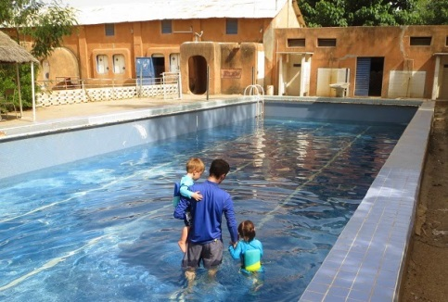
So you don’t think our life is all serious and grueling, we wanted to share that we went to a pool a few days ago! Yes, there is one pool in “the Ville” left over from the French presence here, which we can pay $12 for our family to get into. We went with a missionary family we just met who has kids similar ages to ours, and we discovered that they have a well they pump the water from and are located near the seasonal river of the area, so have pretty good supply of water. We had tried this pool before, but had come on the day of the week that they empty the whole pool and refill it again. That day the water was a somewhat questionable color and was only up to my chest in the deep end, so it wasn’t a very good experience. But this more recent trip was a lot of fun and good fellowship for the whole family, so we are very thankful to have this option. The silly part is that now that our bodies are adjusted to being hot all the time and we’re entering the colder/dry part of the year when the temps go down farther at night, there was even some complaining about the water being too cold on a 90+ degree day!
The Life of a Guard’s Wife
Tragically our guard died recently in a car accident. It has really highlighted for us how difficult life is for most people here. One of his wives has lived in the guard house of our property, but he was never really a guard for us in the traditional sense (even though guardians have a long tradition here and you see several sitting outside their gates during the day on most main roads). Instead he did odd jobs including driving a motorcycle taxi during the day and slept here some nights. His wife is from a nearby village, and I originally thought her life here wasn’t very different than village life. She sleeps in a one room house smaller than many of the dorm rooms I’ve had, with 2-3 children (her teenage son sleeps somewhere else, so we didn’t realize how he was related).
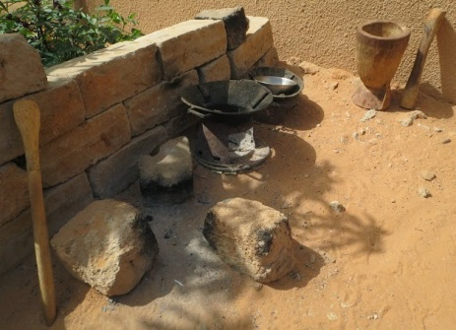
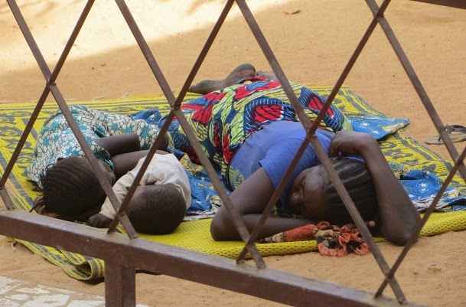
She cooks over an open fire and washes clothes, plucks chickens and spends most of her time in the small enclosure of our yard. Most of her possessions lay out in the open or in sacks around the yard, as well as some good sturdy mats on which she does various things from drying millet to resting with sick children, or visiting with friends. Soon she’s going back to her village to stay with her parents, as she’s not supposed to go outside to work or visit for five months of mourning, and so she needs someone to take care of her. Through this process I was surprised to realize that her life in the village will probably be more difficult than I expected because of the things I take for granted here, like the water she can get from a spigot only across the yard (when it's flowing), the electric light inside her concrete block house, and the closer proximity to basic goods in the various markets here.
Hopefully she will have good support from her family and will find protection through another marriage, but we are still so sad for her and the even less solid social situation of her children. Having a new guard will take some getting used to, but I hope to appreciate the difficulty of his family’s life and situation a little more carefully as we go forward.

Going Nuts
We already mentioned that we’re excited to have a number of fruit trees in our yard, planted a few years ago by the owner. Unfortunately none of them have yielded any fruit ripe enough to eat even though we water them every few days. Maybe this is because the adolescents that come and go (it’s unclear if they’re related to our guard’s family) seem to pick off whatever they see on the trees no matter how small/unripe it is. We’re still working on how to manage that in the right way.

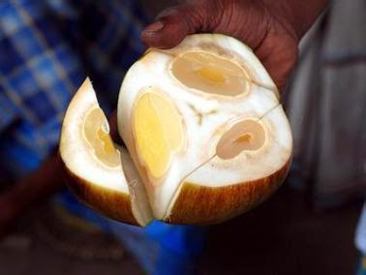
Recently we almost went nuts about the two very tall palm trees in the back of the house that were almost built into the property wall. One is a date palm and the other is some kind of nut we’ve never seen before (Deleb palm = giginya). This second tree has a lot of green nuts hanging on it, although we were told they need to turn orange/reddish to show they’re ripe. A few times we’d seen boys attempting to climb the tree, but it’s very tall. This time they got out a rough wooden ladder and then pulled themselves up the lowest leaves , and proceeded to lop off most of the bunches of nuts with a machete.
You chop the nut into thirds and there is a small ball of pear-like material in the middle of each third, which is supposed to be sugary sweet. We were a little miffed to be offered only a couple nuts off of what we were told was now “our tree” before the rest of them disappeared, but more upset that the inner “fruit” wasn’t even tasty because it wasn’t close to being ripe. It was easy enough to let this one go because I figure I wasn’t going to do any crazy acrobatics to get the strange nuts off the tree anyway. But once again with our fruit we come up against the tension between having and sharing, wasting and saving, and a communal vs. individual mentality.

